Test Case: tc002_SPX_Dev5_Crear_Requisicion_Spot_Con_FAD_Tipo_Cobro_CC
Step 1 - Enter username and password and click to button Enter : Credentials Entered
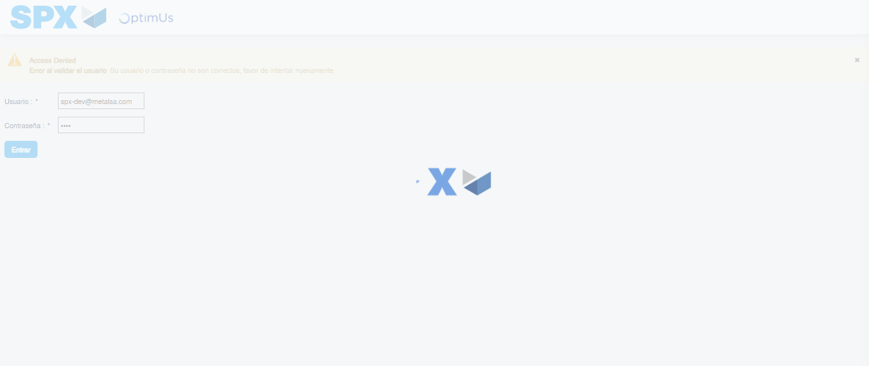Image file-name: QC_Testing-tc002_SPX_Dev5_Crear_Requisicion_Spot_Con_FAD_Tipo_Cobro_CC-1783354414868

Step 2 - Select to UEN and Access to Spot Buy Requisitions : UEN Correctly selected and Correct access
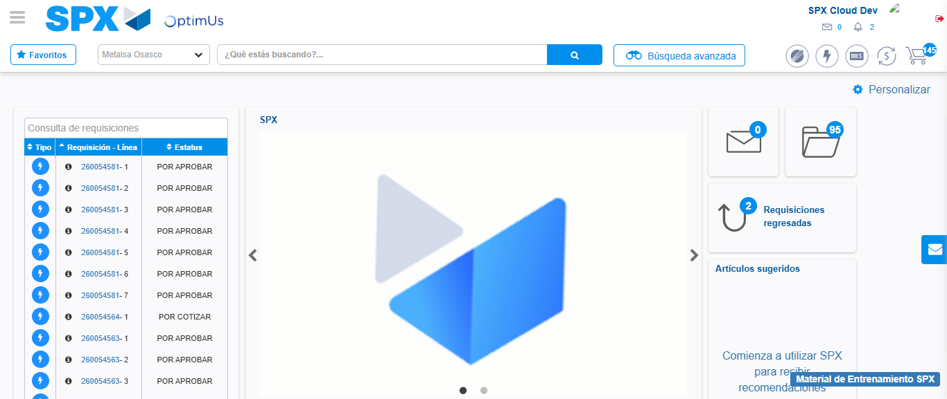Image file-name: QC_Testing-tc002_SPX_Dev5_Crear_Requisicion_Spot_Con_FAD_Tipo_Cobro_CC-1783354440638

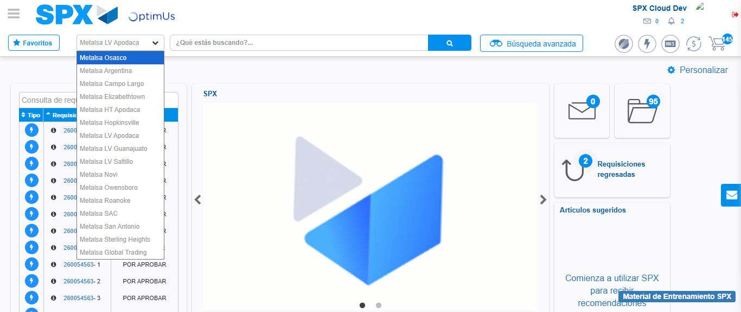Image file-name: QC_Testing-tc002_SPX_Dev5_Crear_Requisicion_Spot_Con_FAD_Tipo_Cobro_CC-1783354443412

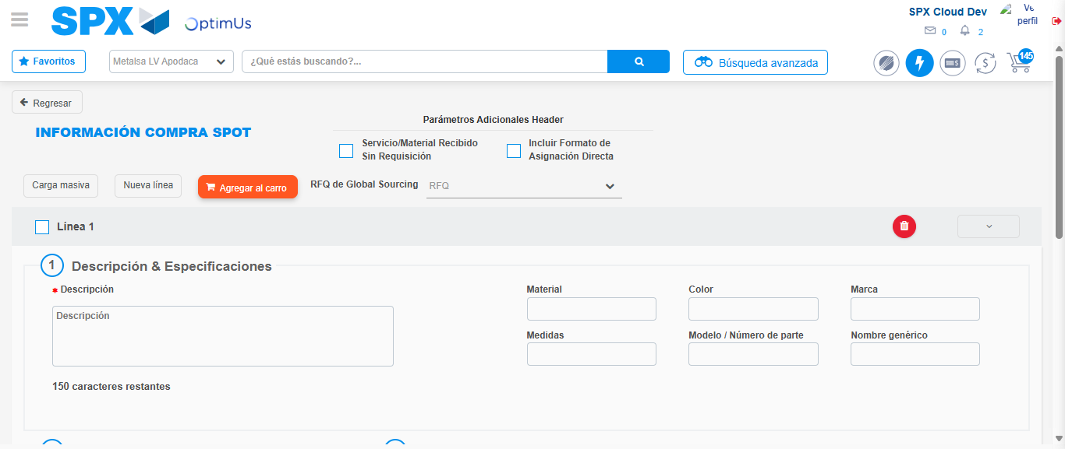Image file-name: QC_Testing-tc002_SPX_Dev5_Crear_Requisicion_Spot_Con_FAD_Tipo_Cobro_CC-1783354462895

Step 3 - Add FAD to Requisition: FAD Successfully Added
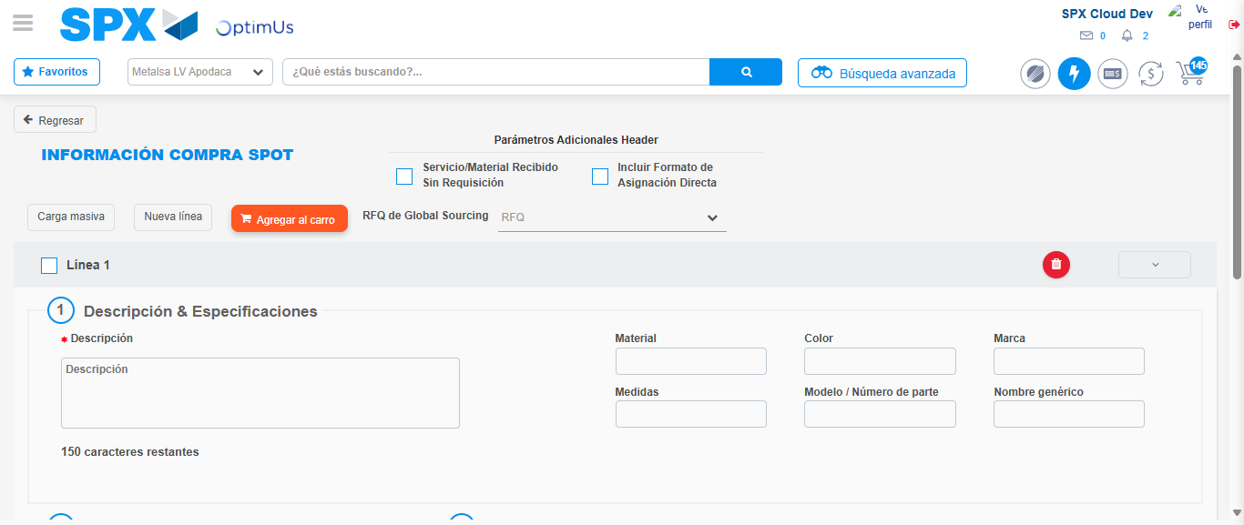Image file-name: QC_Testing-tc002_SPX_Dev5_Crear_Requisicion_Spot_Con_FAD_Tipo_Cobro_CC-1783354463221

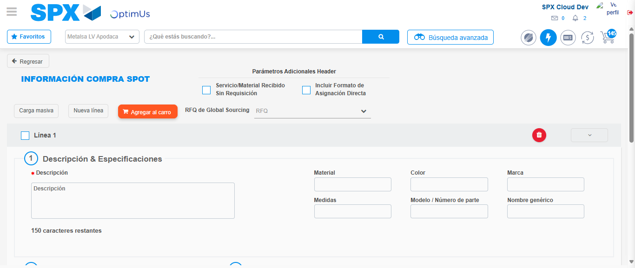Image file-name: QC_Testing-tc002_SPX_Dev5_Crear_Requisicion_Spot_Con_FAD_Tipo_Cobro_CC-1783354463385

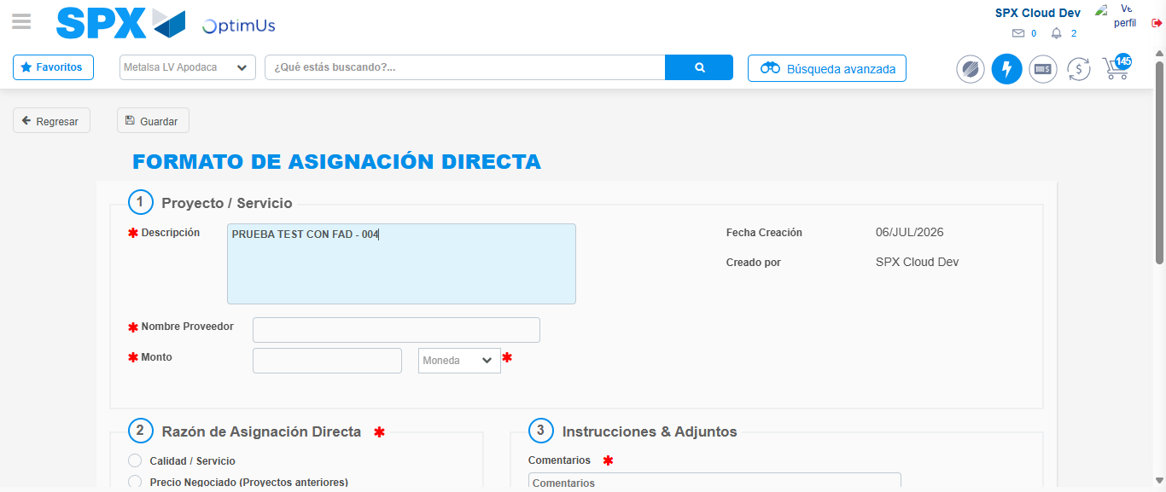Image file-name: QC_Testing-tc002_SPX_Dev5_Crear_Requisicion_Spot_Con_FAD_Tipo_Cobro_CC-1783354466086

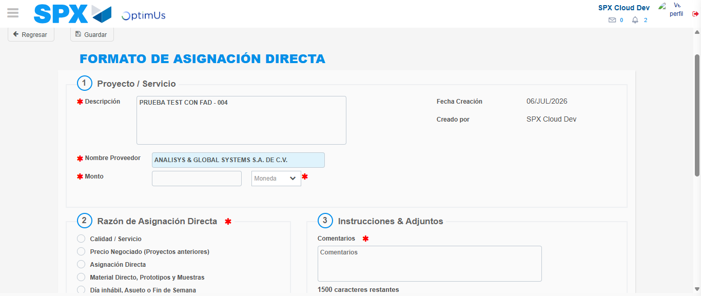Image file-name: QC_Testing-tc002_SPX_Dev5_Crear_Requisicion_Spot_Con_FAD_Tipo_Cobro_CC-1783354472396

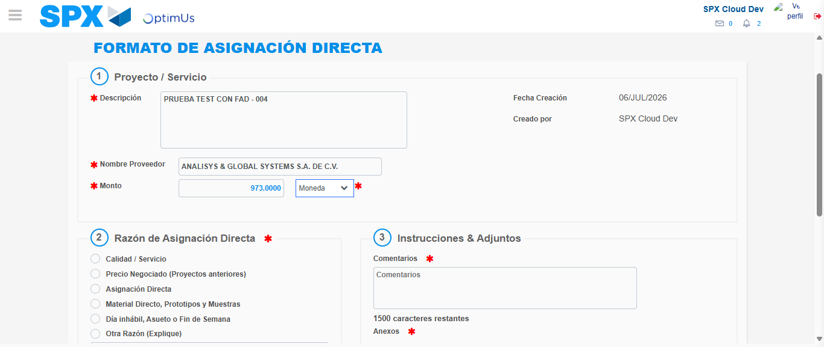Image file-name: QC_Testing-tc002_SPX_Dev5_Crear_Requisicion_Spot_Con_FAD_Tipo_Cobro_CC-1783354472816

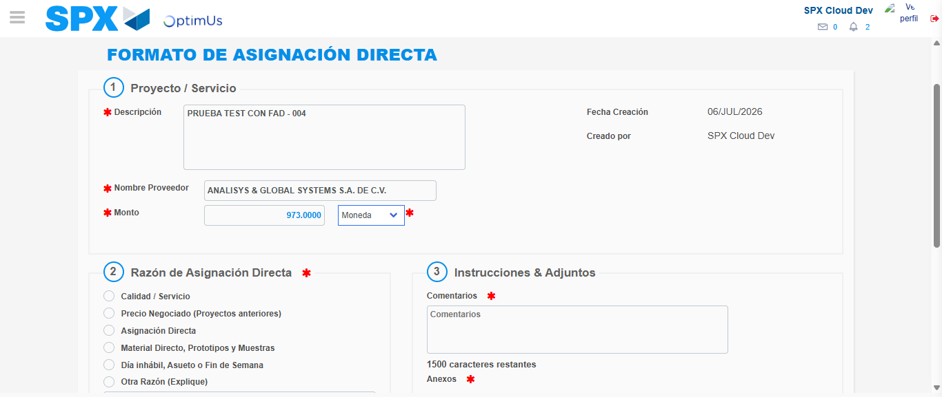Image file-name: QC_Testing-tc002_SPX_Dev5_Crear_Requisicion_Spot_Con_FAD_Tipo_Cobro_CC-1783354472999

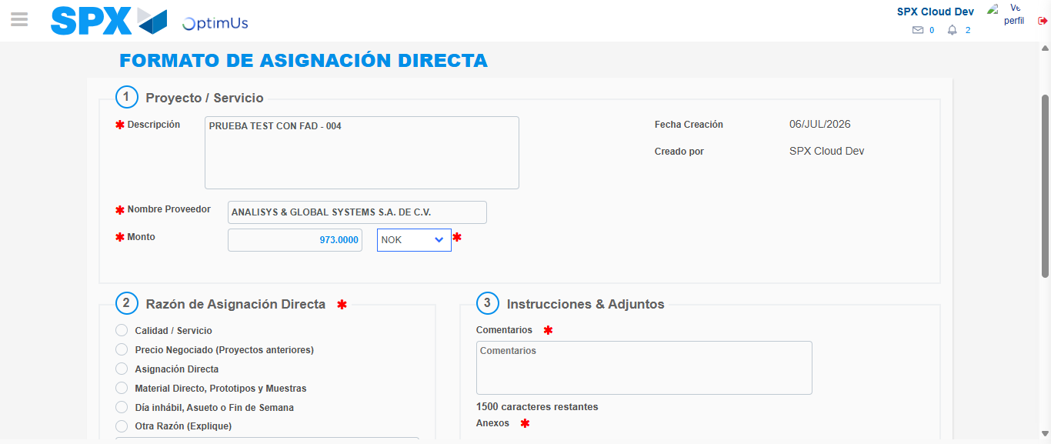Image file-name: QC_Testing-tc002_SPX_Dev5_Crear_Requisicion_Spot_Con_FAD_Tipo_Cobro_CC-1783354473342

Image file-name: QC_Testing-tc002_SPX_Dev5_Crear_Requisicion_Spot_Con_FAD_Tipo_Cobro_CC-1783354473514

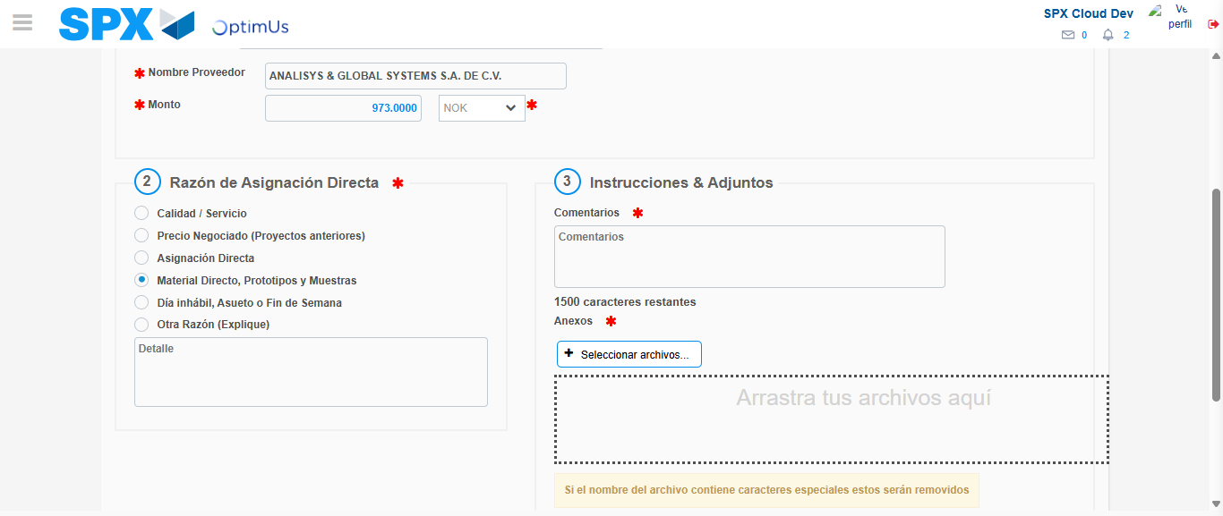Image file-name: QC_Testing-tc002_SPX_Dev5_Crear_Requisicion_Spot_Con_FAD_Tipo_Cobro_CC-1783354474380

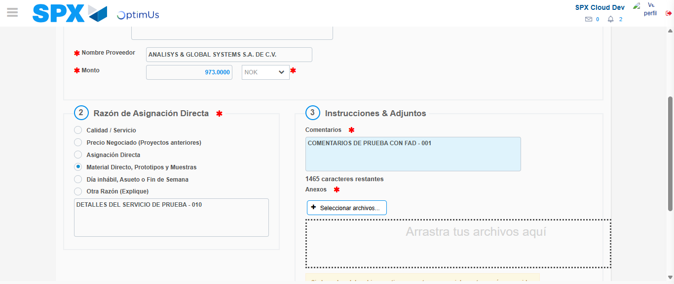Image file-name: QC_Testing-tc002_SPX_Dev5_Crear_Requisicion_Spot_Con_FAD_Tipo_Cobro_CC-1783354485334

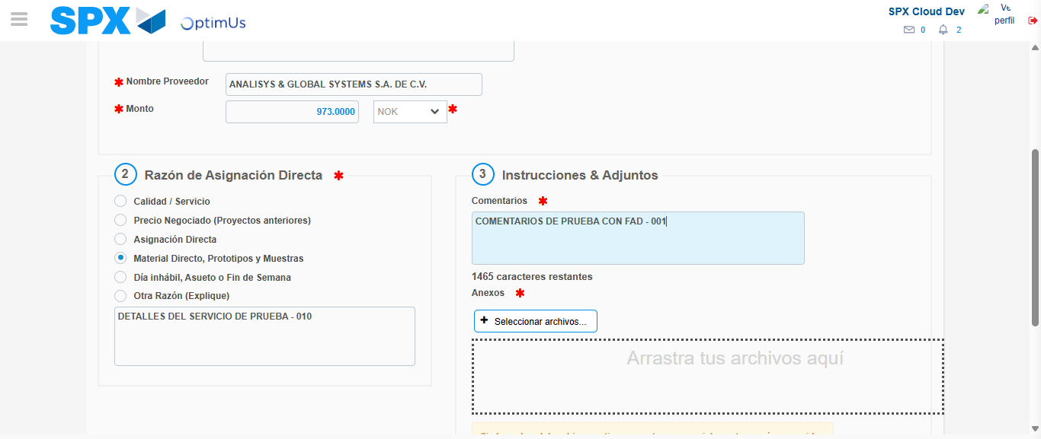Image file-name: QC_Testing-tc002_SPX_Dev5_Crear_Requisicion_Spot_Con_FAD_Tipo_Cobro_CC-1783354486010

Step 4 - Data Capture Spot Buy Requisition: Data captured correctly
Image file-name: QC_Testing-tc002_SPX_Dev5_Crear_Requisicion_Spot_Con_FAD_Tipo_Cobro_CC-1783354463221

Image file-name: QC_Testing-tc002_SPX_Dev5_Crear_Requisicion_Spot_Con_FAD_Tipo_Cobro_CC-1783354463385

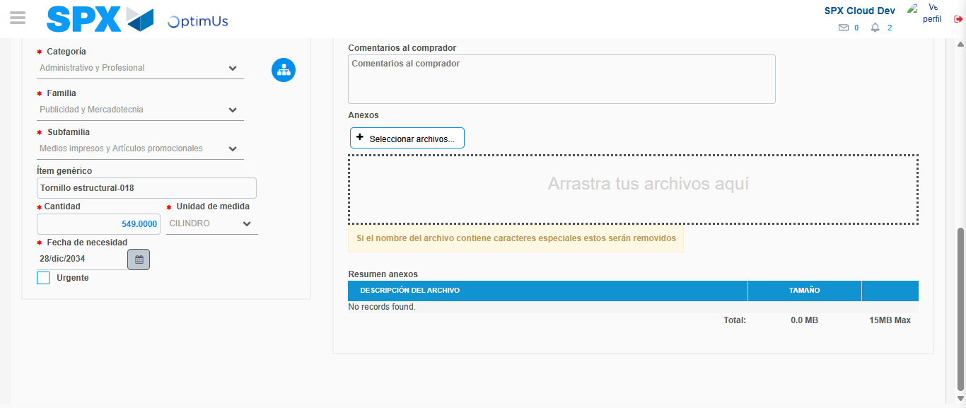Image file-name: QC_Testing-tc002_SPX_Dev5_Crear_Requisicion_Spot_Con_FAD_Tipo_Cobro_CC-1783354497443

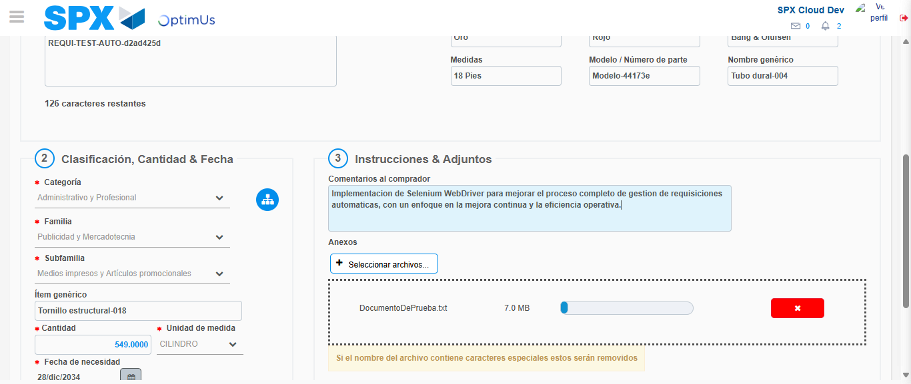Image file-name: QC_Testing-tc002_SPX_Dev5_Crear_Requisicion_Spot_Con_FAD_Tipo_Cobro_CC-1783354498158

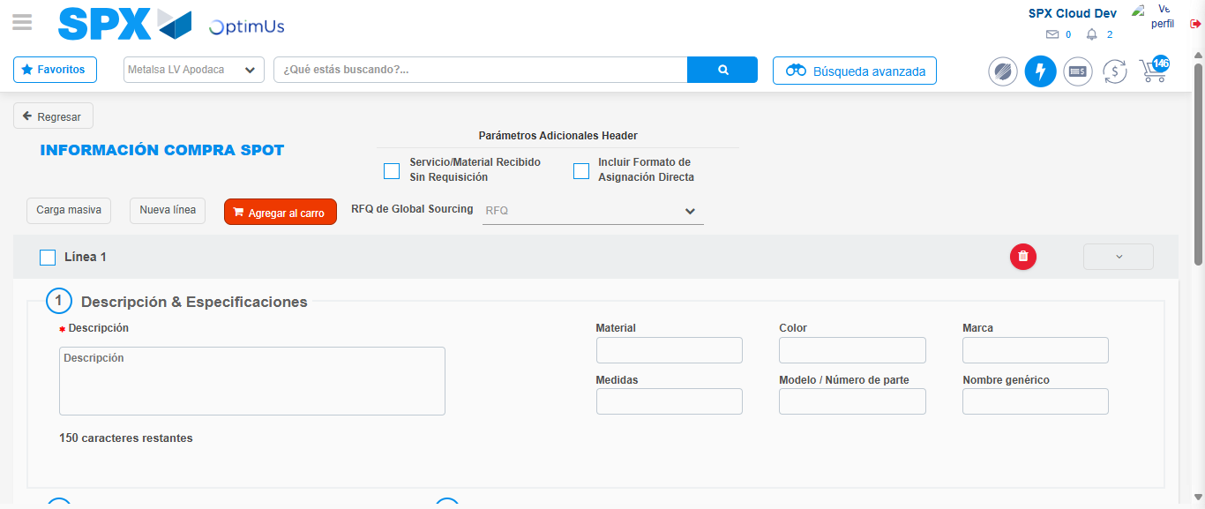Image file-name: QC_Testing-tc002_SPX_Dev5_Crear_Requisicion_Spot_Con_FAD_Tipo_Cobro_CC-1783354506208

Step 8 - Return to Main Page SPX : Return to Main Page SPX
Image file-name: QC_Testing-tc002_SPX_Dev5_Crear_Requisicion_Spot_Con_FAD_Tipo_Cobro_CC-1783354440638

Image file-name: QC_Testing-tc002_SPX_Dev5_Crear_Requisicion_Spot_Con_FAD_Tipo_Cobro_CC-1783354443412

Image file-name: QC_Testing-tc002_SPX_Dev5_Crear_Requisicion_Spot_Con_FAD_Tipo_Cobro_CC-1783354462895

Image file-name: QC_Testing-tc002_SPX_Dev5_Crear_Requisicion_Spot_Con_FAD_Tipo_Cobro_CC-1783354508448

Image file-name: QC_Testing-tc002_SPX_Dev5_Crear_Requisicion_Spot_Con_FAD_Tipo_Cobro_CC-1783354508603

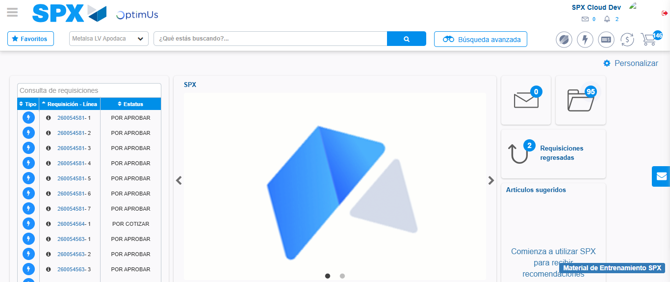Image file-name: QC_Testing-tc002_SPX_Dev5_Crear_Requisicion_Spot_Con_FAD_Tipo_Cobro_CC-1783354529684

Step 9 - Log Out : Log Out SPX
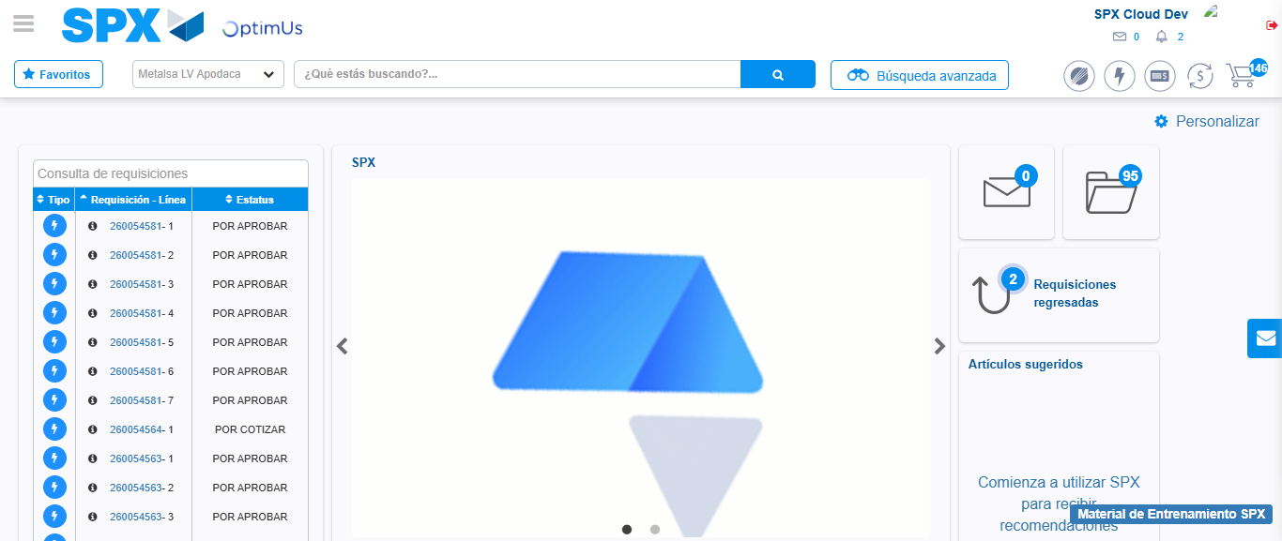Image file-name: QC_Testing-tc002_SPX_Dev5_Crear_Requisicion_Spot_Con_FAD_Tipo_Cobro_CC-1783354529998

